Exploring Physics Stage 3 Set 7

1. V = 980 km h-1 EMF = v B
= 272.2 m s-1 = 60 x 272.2 x 3.5 10-5
B = 3.5 x 10-5 T EMF = 5.7 x 10-1 V
d = 60 m
EMF = ?

2(a) P = VI
50 = 0.9 x 240 x I
I = 2.3 x 10-1 A

(b) Heat energy produced by the transformer may affect the functioning of the other electronic components in the television set. The vents allow the heat to escape from the set.

3. When the magnet is moved into the coil, the approaching magnetic field of the magnetic north pole induced a current in the coil. When the magnet was withdrawn from the coil it again induced a current in the coil - but in the opposite direction as indicated by the galvanometer. This is consistent with Lenz's Law.

4(a) The magnetic field produced by the current flowing through the primary coil induces a current in the secondary circuit. The current only flows for a brief period of time as the magnetic flux produced in the primary coil quickly reaches a maximum value.

(b) Increase the current flowing in the primary circuit.
Increase the number of coils in the primary circuit.

(c) In the opposite direction to the primary circuit or anticlockwise.

5. 60km h-1 a) EMF = l v B
= 0.5 x 16.67 x 2.5 x 10-5
= 2.1 x 10 -4 V

b) Rate of flux change = BA A = 16.67 x 0.5 m2 in 1 sec
= 2.5 x 10-5 x 16.67 x 0.5
= 2.1 x 10-4 Wb s-1

6. If the opposite of Lenz's Law was to occur the induced current would produce a magnetic flux in the same direction as the magnetic flux that induced the current. This increased magnetic flux would produce a larger current which in turn would produce a greater magnetic flux etc. This process would continue to produce an indefinite current in the motor and burn the motors out (and disobey the law of conservation of energy!)

7. EMF = - N 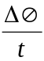 = BA
= 200 x 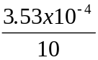 = 0.5 x (1.5 x 10-2)2
= 7.1 x 10-3 V = 3.53 x 10-4 Wb
8(a) EMF = - N
= 1 x 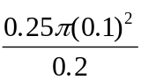
= 3.9 x 10-2 V
(b) & (c)
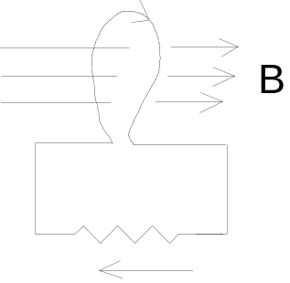
direction of induced current

(d) V = I R
3.9x10-2 = I x 5
I = 7.9 x 10-3 A

9(a) EMF = l v B

V = 80 km h-1 = 1.0 x 22.2 x 3.6 x 10-5 T
= 22.2 m s-1 = 8.0 x 10-4 V

10(b) For the vertical component directed up out of the ground the electrons in each axle will experience a force which will move them towards the end of axle facing towards the south east.

10. As the aluminium plate falls through the magnetic field an EMF is induced in the plate. The induced current produces a magnetic field which opposes the external magnetic field. This causes the plate to slow down as it falls through the field. As the plate leaves the field the direction of the induced current changes, as does the magnetic field it produces. This also causes the plate to slow down, but as it leaves the external magnetic field. This damping effect cause the plate to come to a stop more quickly than if the external magnetic field was absent.

11. 50 cycles in 1 sec, ¼ cycle in 5.0 x 10-3 s
EMF = - N

180 = N x 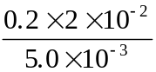

12(a) EMF = l v B (b) F = I l B
10 x 10-3 x 2.5 = 20 x 10-3 x V x 0.5 = 10 x 10-3 x 20 x 10-3 0.5
V = 2.5 m s-1 = 1.0 x 10-4 N

13.

a.

n = 300 turns emf = 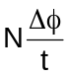 buy φ₂ = 0 in ¼ of a turn so Δφ = BA
A = 0.2 x 0.2 240 = 300 x 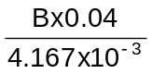
= 0.04 m² B = 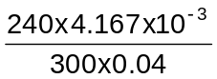
emf = 240 V
B = 0.0833 T
60 rev = 1 s
¼ rev = T
T = 4.167 x 10⁻³ s

b. As induced emf = 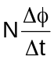 and φ = BA, peak voltage produced when A is maximum and minimum voltage when A is minimum.

